**Sequence diagram**

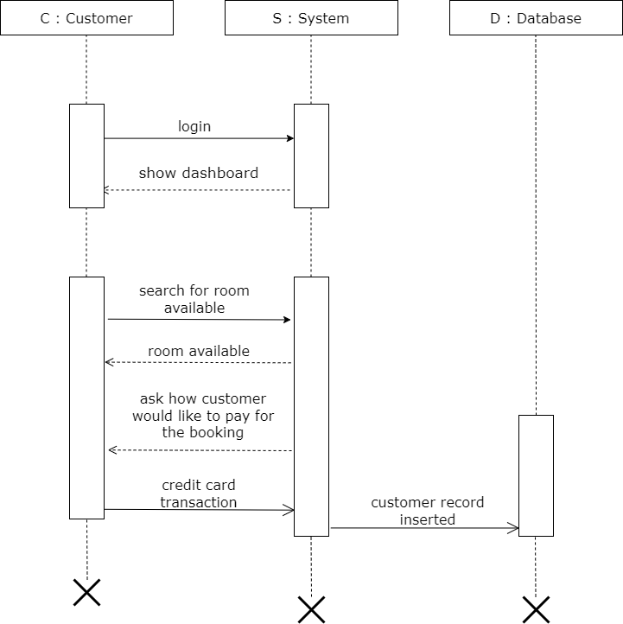

Figure 1.1 sequence diagram for room booking

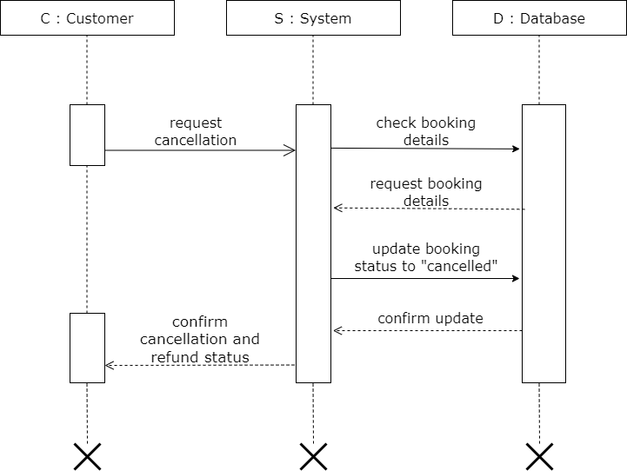

Figure 1.2 sequence diagram for cancel booking

**State diagram**

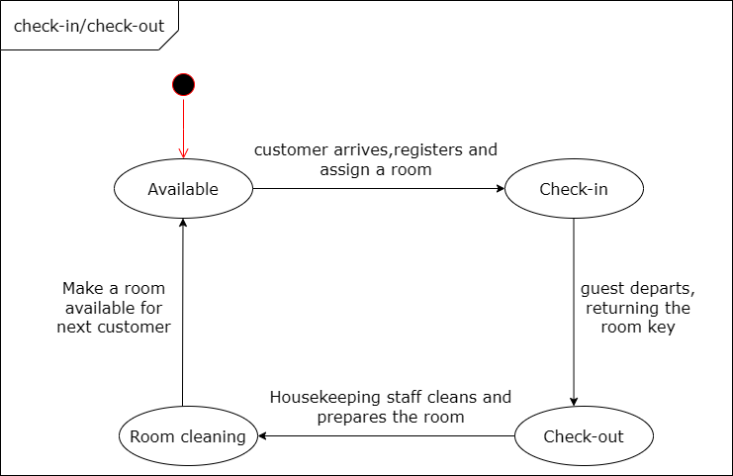

Figure 2.1 state diagram for check-in / check-out